Sprint Retrospective – 22.04

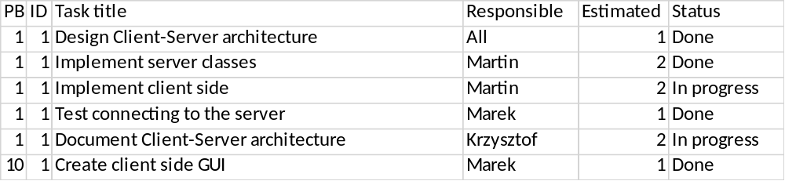

This sprint started the Elaboration phase of UP.

In the first sprint we have decided to work on client-server architecture from our product backlog. Tasks were split between team members as shown in table. We have fully implemented the server side and the client side needed some improvements. The documentation for the client-server has been started. The GUI for client side has been created in this sprint too.

